You can access online training at the KSCB website: <http://www.knowsleyscb.org.uk/multi-agency-training/>

Savera Liverpool will be delivering training regarding Harmful Practices, please see the attached flyer for more details.



It is important that frontline practitioners are aware that such practices are happening and that they may come across families who are affected or experiencing such abuse.

Click here for more information: [www.gov.uk/forced-marriage](http://www.gov.uk/forced-marriage) [www.forwarduk.org.uk](http://www.forwarduk.org.uk) Local advice contact Savera on [saveraliverpool@hotmail.co.uk](mailto:saveraliverpool@hotmail.co.uk) Helpline: 07716 266 484

**Female Genital Mutilation (FGM)** The World Health Organisation (WHO, 2010) has classified FGM as: “all procedures that involve partial or total removal of the external female genitalia, or other injury to the female genital organ for non-medical reasons”

In England, Wales and Northern Ireland all forms of FGM are illegal under the Female Genital Mutilation Act 2003. Scotland has its own FGM Act.”

**Honour Based Violence** (HBV) can be described as a collection of practices, which are used to control behaviour within families or other social groups to protect perceived cultural and religious beliefs and/or honour. Such violence can occur when perpetrators perceive that a relative has shamed the family and/or community by breaking their honour code (Crown Prosecution Service)

**Forced Marriage**

A Forced Marriage (FM) is a marriage in which one or both spouses do not (or, in the case of some adults with learning or physical disabilities, cannot) consent to the marriage and duress is involved. Duress can include physical, psychological, financial, sexual and emotional pressure (UK Forced Marriage Unit, 2009). Forced Marriage is now a specific offence under s121of the Anti-Social Behaviour, Crime and Policing Act 2014.

They are also often committed as a result of family members who mistakenly believe someone has brought shame to their family or community that isn’t in keeping with their traditional beliefs of their culture

Harmful practices are forms of violence which have been committed primarily against women and girls in certain communities and societies for so long that they are considered, or presented by perpetrators, as part of accepted cultural practice.

**7 MINUTE BRIEFING**

**Harmful Practices: Female Genital Mutilation, Forced Marriage and Honour Based Violence**

6

5

2

1

7

4

3

7

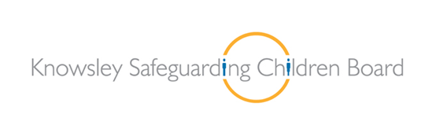

7

**7 Minute**

**Briefing**

**7 Minute Briefing: Local Lessons**

**7**

**6**

**5**

**4**

**3**

**2**

**1**