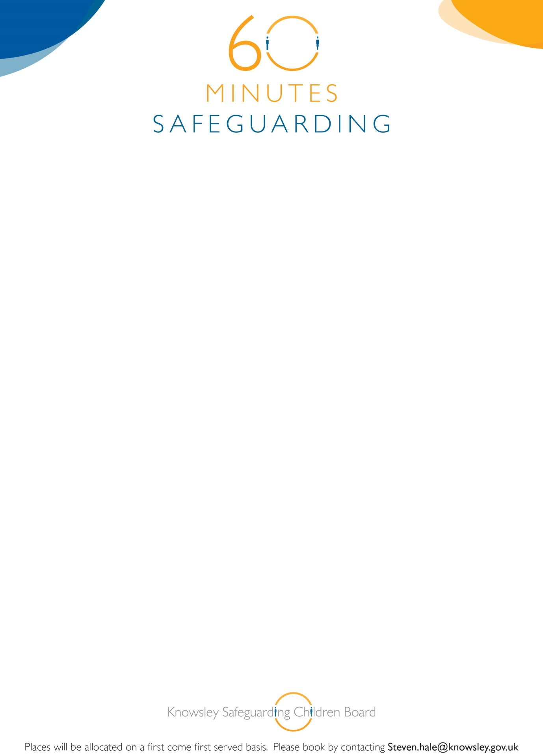

**Knowsley Safeguarding Children Board**

**60 Minute Safeguarding Session**

**Bruising in Non Mobile Babies**

24th June 2015

12.00-1.00pm

YOS Training Room

Nutgrove Villa

Westmoreland Road

Huyton L36 6GA

**Linda Teebay**

**Designated Doctor**

**Booking is essential for this brief but informative awareness session. If you book on and are unable to attend, please inform us prior to the briefing or you may be charged. See booking details below:**