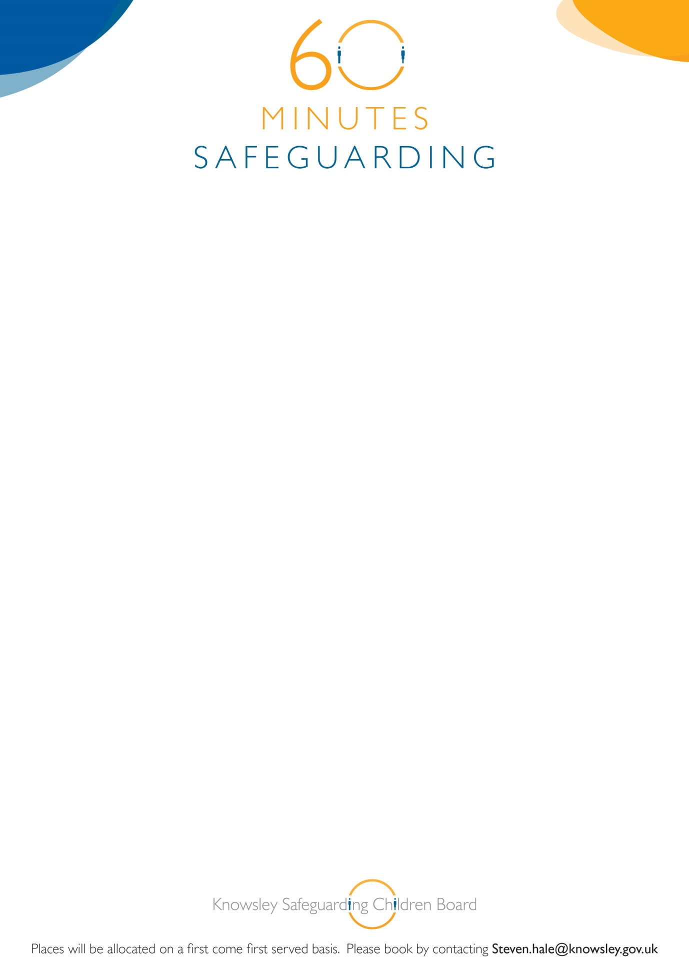

**Knowsley Safeguarding Children Board**

**60 Minute Safeguarding Session**

**Child Sexual Abuse**

26th October 2015

12.00-1.00pm

YOS Training Room

Nutgrove Villa

Westmoreland Road

Huyton L36 6GA

**Linda Teebay**

**Designated Doctor**

**Booking is essential, if you book and but are are unable to attend, please inform us prior to the briefing or you may be charged. See booking details below:**