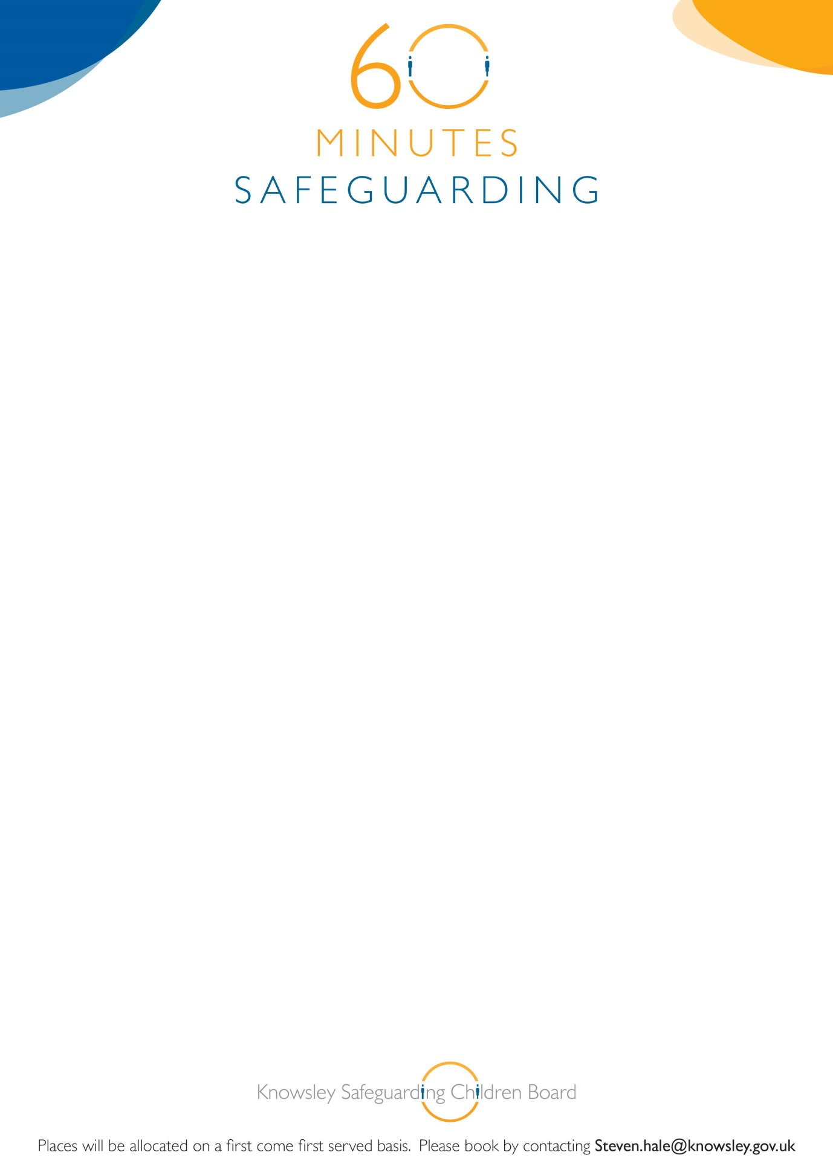

**Knowsley Safeguarding Children Board**

Launch

**‘60 Minutes Safeguarding Sessions’**

**CSE Awareness**

On Wednesday 18th March

12.00-1.00pm

The Venue Civic Way Huyton L36 6GD

To coincide with

**National CSE Awareness day**

Book on to this brief but informative awareness session