**For more information**:

MindEd is a free educational

 resource on children and young

people’s mental health for all adults. <https://www.minded.org.uk/>

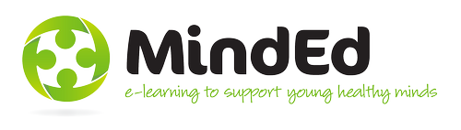

National CAMHS website

<http://mycamhschoices.org/>

5 Boroughs CAMHS website for

young people

<http://camhswhoami.co.uk/>



**Things to consider**

Young people should be given the

option to attend CAMHS, even if we as porfessionals think it is in their best interest – it can be difficult to engage young people who do not wish to attend

CAMHS interventions are focused on mental health difficulties. Therefore, other agencies may be better placed to respond to social/contextual issue i.e domestic violence, housing

difficulties etc.

**How to refer to us**

We accept referrals from a wide range of sources including: school, social care, GP, education psychology, paediatricians,

health visitors, other agencies and self-referrals.

To refer to us please call

01925 579 405

**Interentions**

**offered**

Family therapy, CBT, play

therapy, guided self-help, development of coping

strategies, formulation of

difficutlies (a comprehensive understanding of the problem) a variety of therapeutic modalities, medication, liaison with other agencies (e.g. schools and social care), risk assessment and management, neuropsychological assessment

**Who we are**

Professionals who

work in CAMHS include: psychiatrists,

clinical psychologists, nurses, social workers,

family therapists, psychotherapists and administrative staff.

**Tier 2** – for brief, time-limited interventions

for mild-moderate mental health difficutlies

**Tier 3** – for longer interventions for

moderate-severe mental

health problems

**What is CAMHS?**

CAMHS is a specialist multi-disciplinary service that offers support to young people and their families experiencing a range of mental health problems. These might include: depression, anxiety, OCD, self-harm, phobias, distress as a result of physical health conditions. This list is not exhaustive.

**Statistics**

10% of children and young people suffer from a mental health

Between 6 to 8.5% children and young people deliberately self-harm

More than half of all adults with mental health problems were diagnosed in childhood. Less than half were treated

appropriately at the

time

**7 MINUTE BRIEFING**

**Child and Adolescent Mental Health Service (CAMHS)**

6

5

2

1

7

4

3

7

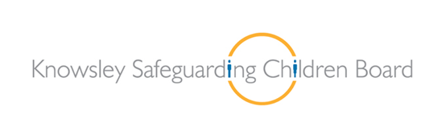

7

**7 Minute**

**Briefing**

**7 Minute Briefing: Local Lessons**

**7**

**6**

**5**

**4**

**3**

**2**

**1**